Modeling and Simulation of Non-Linear, Dispersive, Gyromagnetic,

Ferromagnetic Transmission Lines

**Muhammad Shamaas1 and Muhammad Asghar Saqib2**

1, 2Department of Electrical Engineering, University of Engineering and Technology, Lahore 54890, Pakistan

12018msee004@student.uet.edu.pk, 2saqib@uet.edu.pk

**Abstract** –*S*

**Keywords:**I

# **Introduction**

In

# **System Analyzed**

The

# **MEEP Simulation**

The software used for the electromagnetic simulation of the Magnetic Transmission Lines is the Finite Difference Time Domain simulator MEEP. Maxwell’s Equations are discretized using central difference approximations to the space and time partial derivatives. The different field components at a grid location are stored in the edges and faces of a cubic element called Yee’s Cell. They are evolved in discrete time steps .

Faraday’s Law can be expanded as follows:

Similarly, Ampere’s Law can be approximated as follows:

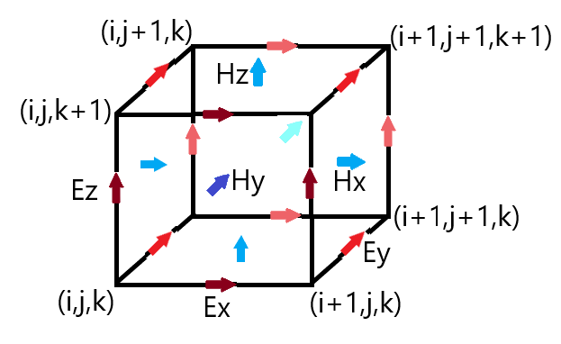

The simulator can simulate anisotropic, non-linear, dispersive and gyromagnetic materials.

1. Dispersive Media: Drude-Lorentzian Model models frequency dependent permittivity and permeability. It explains the electrodynamic properties of metals by regarding conduction band electrons as non-interacting electron gas. When the material is excited by an external source of resonant frequency, the material absorption loss increases greatly. Electromagnetic Energy is converted into other forms of energy. Flux Densities contain terms for infinite frequency response and frequency dependent Polarization vector.

and are represented as a sum of harmonic resonances and a term for frequency independent electric conductivity.

is the electrical/magnetic conductivity. is the oscillator strength, is the angular resonance frequency, is a damping factor.

1. Nonlinear Media: The Pockels and Kerr Non-linearity model explains how ε and μ can change as a function of the field intensity. Ferromagnetic materials are non-linear as their permeability varies with the strength of applied field intensity. At high magnetic field intensity, the material saturates, limiting further increase of Magnetic Flux. Hence, the susceptibility decreases rapidly.

sum is the Pockels effect constant; whereas sum is the Kerr effect constant.

1. Gyrotropic Media: Landau-Lifshitz-Gilbert model describes the precessional motion of saturated magnetic dipoles in a magnetic field.

describes the linear deviation of magnetization from its static equilibrium value. Precession occurs around this unit bias vector . represents oscillator strength, is the angular resonance frequency, is the oscillator damping factor.

# **Analysis of Protection Schemes**

The

# **Proposed Protection Scheme**

The

# **Discussion**

A

# **Conclusion**

Di

# **References**

[1] G. M. Masters, *Renewable and Efficient Electric Power Systems*. John Wiley & Sons, Inc, 2004.